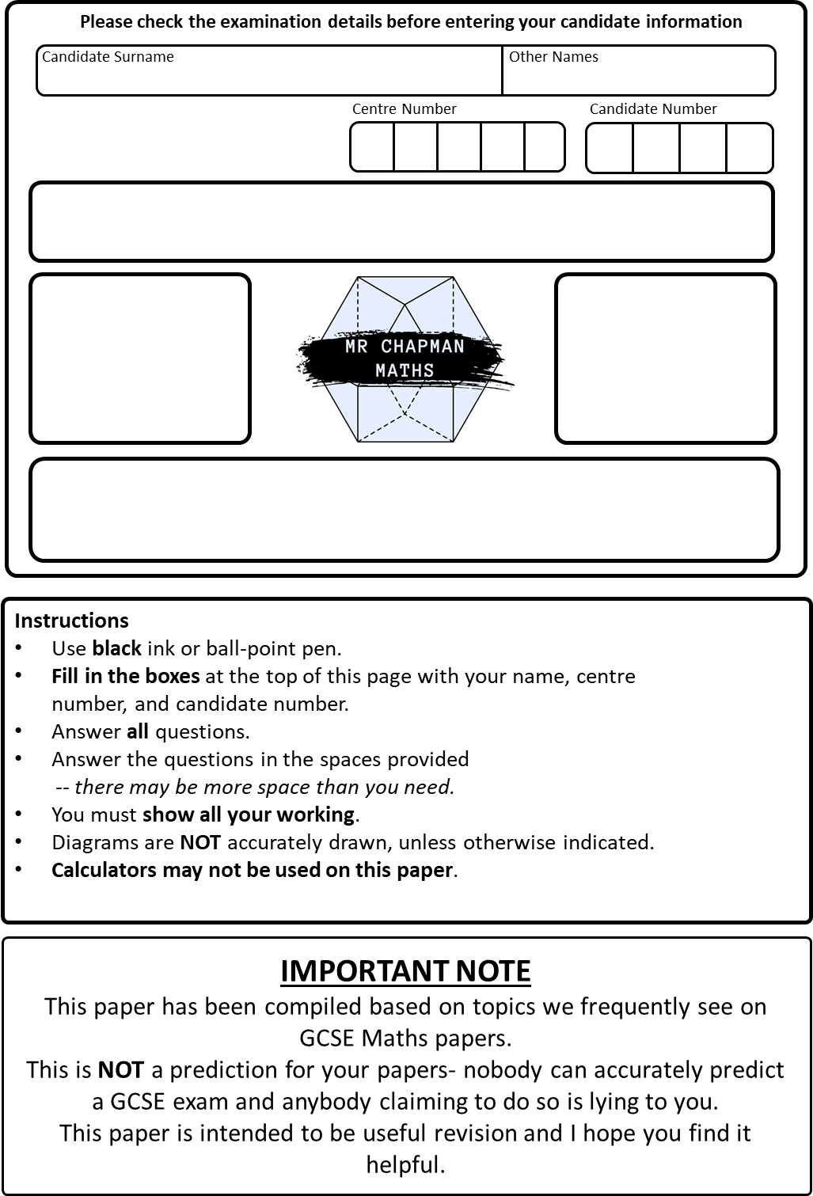
Write your answers in the spaces provided.
Best Guess May 2026
Marks:

GCSE
Higher Tier
Paper 1
Mathematics
You must write down all the stages in your working.
- Amelie, Bea, and Cerys share £220 in the ratio 2:4:5
Work out how much more Cerys receives than Amelie.

……………… (3 marks)
- a. Write 144 as a product of its prime factors.
Give your answer in index form.

……………… (3 marks)
b. Find the Highest Common Factor of 144 and 240.

……………… (2 marks)

- Expand and simplify $4\left(2x-3\right)-2(x+5)$

……………… (2 marks)
- Expand and simplify $(x+2)(2x+1)(x-2)$

……………………………… (3 marks)
- A number, $y$, is truncated to 1 decimal place. The result is $8.4$
Write down an error interval for $y$

………………….$≤y<$…………………. (2 marks)
- Evaluate $8^{\frac{2}{3}}$

…………………… (2 marks)
- Simplify fully
$${\left(3x^{2}y^{4}\right)}^{-2}$$

…………………….. (2 marks)
- Mr Chapman has 5 pairs of trousers, 9 shirts, and 3 ties.
Work out the total number of ways he can choose to wear trousers, a shirt, and a tie.

…………………….(2 marks)
- Show that $2\sin\left(30°\right)+\tan\left(45°\right)=2$

……………………………….. (2 marks)
- Here are the first five terms of a quadratic sequence:
2, 9, 18, 29, 42
Find an expression, in terms of $n$, for this sequence.

……………………………….. (3 marks)

- Bruno organises an obstacle course event at his school and records the time it takes for a group of teachers, in minutes, to complete his obstacle course.
His results are shown in this table
 | Minutes
Range | 26
Lower Quartile | 25
Median | 29
Upper Quartile | 33
Highest Value | 44

- On the grid below, draw a box plot to show the information in the table.
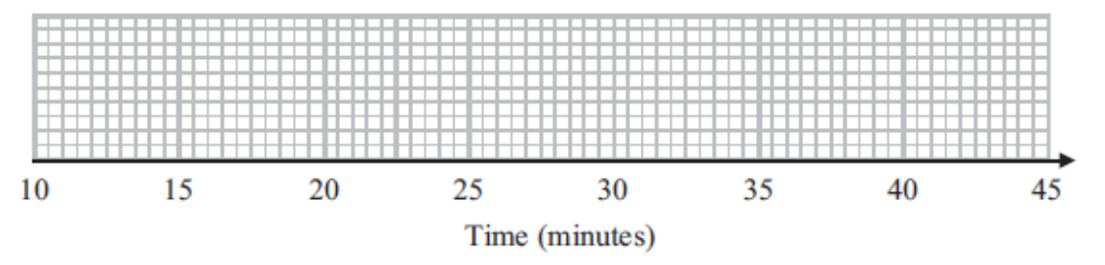

(2 marks)

Bruno also records the time it takes for students in his year to complete the same obstacle course. The box plot below shows this information.
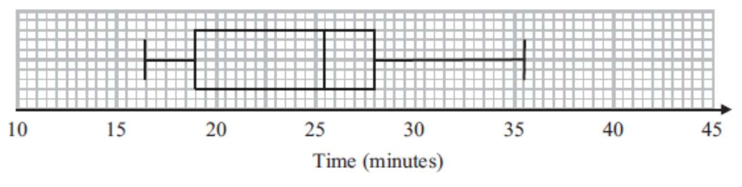
- Compare the distribution of the teachers’ times and the students’ times.

……………………………………………………………………………………………

……………………………………………………………………………………………

……………………………………………………………………………………………

……………………………………………………………………………………………

(2 marks)
Total for question: 4 marks

- Factorise and solve
$$2x^{2}-7x-15=0$$

…………………………………. (3 marks)
- Veronica plays a game of chess and a round of boxing.
The probability that she wins the game of chess is 0.8.
The probability she wins the round of boxing is $0.3$.
Find the probability that she wins exactly one of these rounds.

……………………………………….
(3 marks)

- The coordinates of the turning point of a curve are $(1,4)$
- Write down the coordinates of the turning point of the curve $f(x+3)$

……………………………………
(1 mark)

- Write down the coordinates of the turning point of $-f(x-2)$

……………………………………
(2 marks)
- Rationalise the denominator and simplify fully
$$\frac{15}{3-\sqrt{6}}$$

…………………………………
(3 marks)

- Express as a single fraction in its simplest form
$$\frac{3}{x+2}-\frac{1}{x-5}$$

…………………………………..
(4 marks)

- AED is a straight line
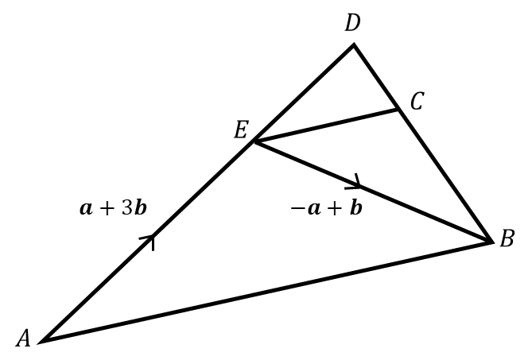
$\vec{AE}=a+3b$
$\vec{EB}=-a+b$

- Work out the vector $\vec{AB}$

………………….
(1 mark)
It is also given that $\vec{ED}=\frac{1}{3}\vec{AE}$ and $\vec{DC}=-\frac{1}{3}a$
- Prove that $EC$is parallel to $AB$.

………………….
(3 marks)

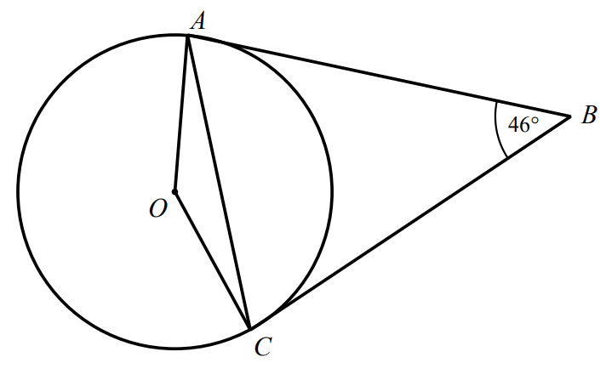
$A$and $C$ are points on the circumference of a circle, centre $O$.
$AB$ and $BC$ are tangents to the circle.

$∠ABC=46°$

Find the size of $∠OAC$.
Give reasons for each stage of your working.

$∠OAC=$…………………………….
(4 marks)
- Given $f\left(x\right)=\frac{2x+1}{3}$and $g\left(x\right)=x^{2}-4$
- Find $f^{-1}(x)$

……………………………………….
(2 marks)
- Find $gf(4)$

…………………………………..
(2 marks)
- Given the inequality
$6<\sqrt[3]{x}$ $<7$
Circle the possible value of $x$from the list below

1.9 | 20 | 45 | 290

(1 mark)

- A solid hemisphere has radius $x$.
A solid cylinder has radius $3x$and height $x$.
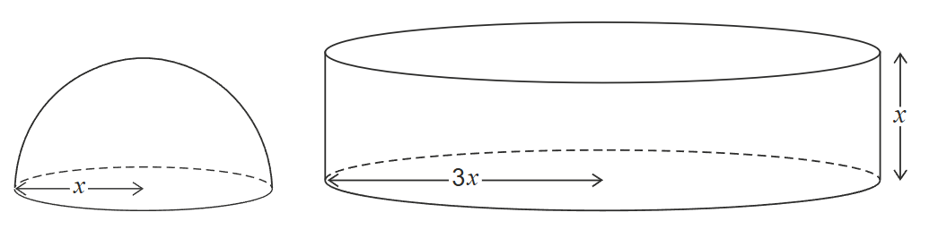
Surface area of a sphere = $4πr^{2}$
Where $r$is the radius
Work out the ratio:
$$surface area of the hemisphere :surface area of the cylinder$$
Give your answer in its simplest form.

(3 marks)
- Make $b$the subject of
$$a=\frac{1}{\sqrt{b+1 }}$$

$b=$ …………………………
(3 marks)

- A, B, and C are points on the axes as shown.
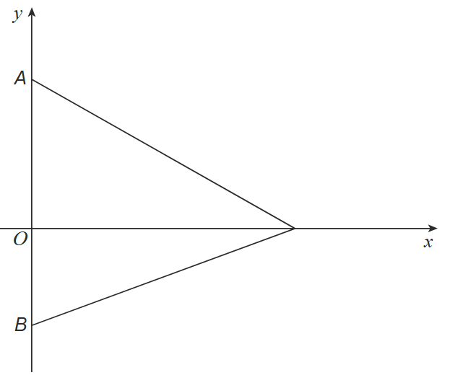
The area of the triangle ABC is $28$square units.
If $A=\left(0,10\right)$ and $B=(0,-4)$, write down the coordinates of C.

……………………….
(2 marks)

- Solve algebraically the simultaneous equations
$$x^{2}+y^{2}=25$$
$$y-x+1=0$$

……………………………
73 (6 marks)
- Simplify
$$8^{4}÷32^{\frac{2}{5}}$$
Give your answer in the form $2^{m}$ where $m$ is an integer

…………………………..
76 (3 marks)

- The vertices of a regular hexagon lie on a circle Centre $O$ and radius $5$cm.
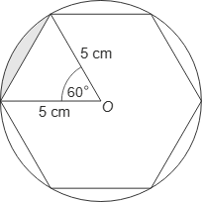
Work out the shaded area.
Give your answer in the form $\frac{aπ-b\sqrt{c}}{12}$ where $a$, $b$, and $c$ are integers.

(4 marks)
TOTAL FOR PAPER = 80 MARKS

