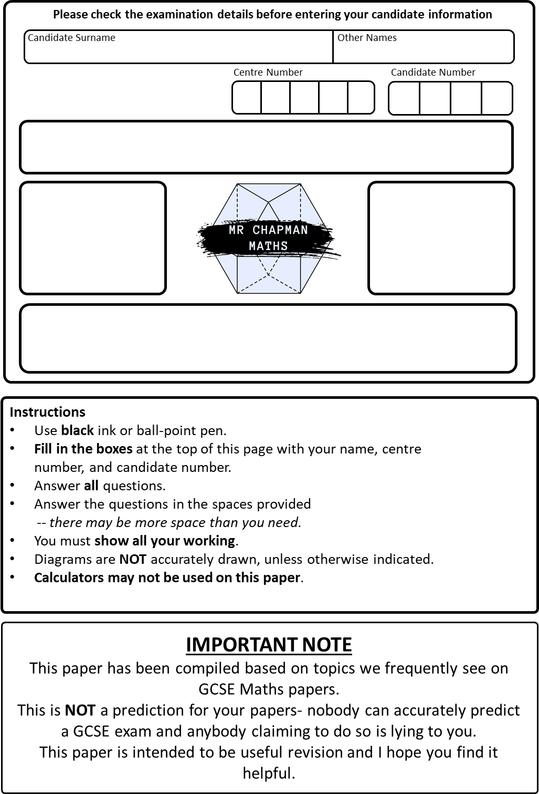
Write your answers in the spaces provided.
Best Guess Paper 1 2026
P
Marks:
/80
GCSE
Foundation Tier
Paper 1
Mathematics
You must write down all the stages in your working.
1. Round $4528$to the nearest $100.$

……………………………
$(1$mark)
2. Write these numbers in order of size, starting with the smallest number.

$$0.92 0.901 0.99 0.099 0.909$$

…………………………………………………………………………
$(1$mark)
3. Convert $4500$grams into kilograms.

…………………………… kg
$(1$mark)
4. Given that $42×35=1470$, write down the value of:
- $4.2×350$

…………………………………………………………………………
(1 mark)

- $1470÷350$

…………………………………………………………………………
(1 mark)

5. Simplify $3x+4y-x+2y$

…………………………………………………………….
(2 marks)

6. Write $0.6$as a fraction in its simplest form.

…………………………………………….
(2 marks)

7. Here is a list of numbers.
$$12, 15, 17, 21, 24, 25$$
From the list, write down:
- A prime number.
……………………………
$(1$mark)
- A multiple of $8$.
……………………………
$(1$mark)
- A factor of $45$.
……………………………
$(1$mark)

8. Work out $\frac{3}{5}$ of $40$.

…………………………………………….
(2 marks)

9. Use the formula $v=u+at$to work out the value of $v$when $u=30$, $a=-3$ and $t=4$.

…………………………………………….
(2 marks)

10. A train leaves Manchester at $08:45$ and arrives into Hitchin at $11:15$.
An adult ticket costs $£42.50$. A child ticket is half the price of an adult ticket.
Amelie buys an adult ticket and two child tickets.

- How long is the journey in minutes?

…………………………………………….
(1 mark)
- How much does Amelie spend on tickets in total?

…………………………………………….
(2 marks)
11. Three angles are on a straight line: $x, 2x,$ and $60°$.

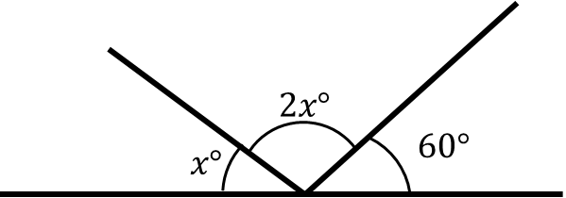

Work out the value of $x$.

…………………………………………
(3 marks)
12. Work out $15\%$of $120$.

…………………………………………….
(2 marks)

13. Factorise $5x+35$

…………………………………………….
(1 mark)

14. Solve $4y-3=57$

…………………………………………….
(2 marks)
15. Work out:
a. $\frac{3}{4}-\frac{7}{10}$

……………………………………………
(2 marks)

- $1\frac{5}{6}×\frac{2}{9}$

…………………………………………
(2 marks)

- $\frac{7}{8}÷\frac{3}{4}$ , giving your answer as a mixed number in its simplest form.

…………………………………………….
(2 marks)

Total for question : 6 marks

16. Alice and Misha share $£45$in the ratio $2:7$
How much more does Misha get than Alice?

………………………………………….
(3 marks)

17. A bag contains red, blue, and green counters only. The probability of choosing each colour is as shown in the table.
Colour | Red | Blue | Green
Probability | $$0.3$$ | $$0.5$$

- Work out the probability of choosing a green counter.

………………………………………
(1 mark)
- There are $60$counters in the bag in total. How many blue counters are there?

……………………………………….
(2 marks)
18. A car travels $120$miles in $2$hours $30$minutes. Calculate the average speed of this car in miles per hour.

…………………………………….. mph
(3 marks)
19. Rufus the dog barks every $9$seconds. Barnaby the cow moos every $12$seconds. They both make a sound at the same time.
After how many seconds do they next make a sound at the same time?

……………………………………………
(2 marks)

20. Granny Alison’s chilli con carne has the following recipe:

Chilli Con Carne
Serves $6$people
- $1$kg beef mince
- $400$g chopped tomatoes
- $3$red chillies
- $600$g kidney beans

Her son wants to use the recipe to make chilli for $15$people.
- Work out how much of each ingredient he will need to use.

…………………………… beef mince
……………… chopped tomatoes
…………………………… red chillies
……………………… kidney beans
(3 marks)
- Granny Alison uses $4.8$kg of chopped tomatoes. How many people is she making chilli for?

……………………………………… people
(2 marks)

21. This table shows the goals scored by Stevenage football club in the last $38$games.
Goals | Frequency
$$0$$ | $$7$$
$$1$$ | $$14$$
$$2$$ | $$11$$
$$3$$ | $$6$$
$4$or more | $$0$$

- Find the median number of goals scored.

…………………………………….
(1 mark)
- Write down the mode.

…………………………………….
(1 mark)
- Write down the total number of goals scored across the $38$games.

……………………………………
(2 marks)

22. A solid prism is shown in the diagram below.
The cross-section is a right-angled triangle.

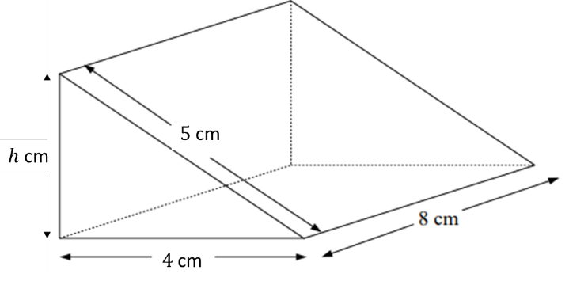
- Find the height of the triangle, $h$.

…………………………………………
(2 marks)

- Calculate the volume of the prism.

……………………………………… $cm^{3}$
(3 marks)
23. Solve the equation:
$$3\left(2x-1\right)=4x+9$$

…………………………………………
(3 marks)

24. There are $200$people in a cinema.
$\frac{1}{4}$ of the people in the cinema are adult men.
$30\%$of the cinema are adult women.
The rest of the people are children.
The children are made up of boys and girls in the ratio $4:5$
How out how many girls are there in the cinema.

………………………………………
(4 marks)

25. The three angles in a triangle are $2x$, $x+30$, and $2x-10$ as shown in the diagram.
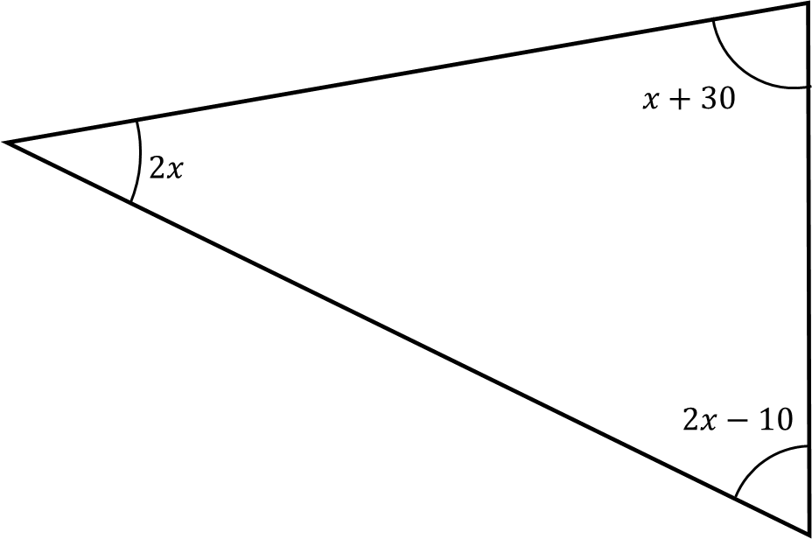
Work out the value of $x$and use it to state the three angles of the triangle.

…………………………………………
(4 marks)

26. A number is chosen at random from the universal set,  .
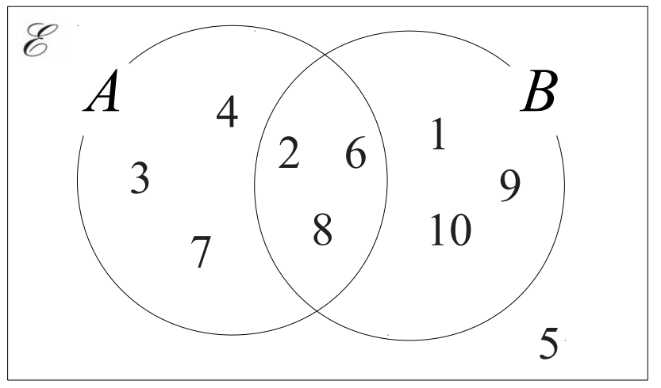
- What is the probability the number is in the set $A∪B$?

………………………
(2 marks)

- What is the probability the number is in the set $B^{'}$ ?

………………………
(2 marks)
27. Solve the simultaneous equations
$$3x-3y=9$$
$$2x+y=12$$

$x=$……………………

$y=$……………………
$(3$marks)

28. Here is a rectangle
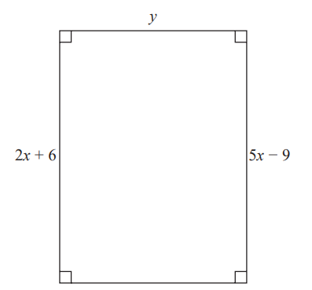
All measurements are in cm.

The area of the rectangle is $48$cm².

Show that $y=3$.

(4 marks)
TOTAL FOR PAPER IS $80$MARKS

