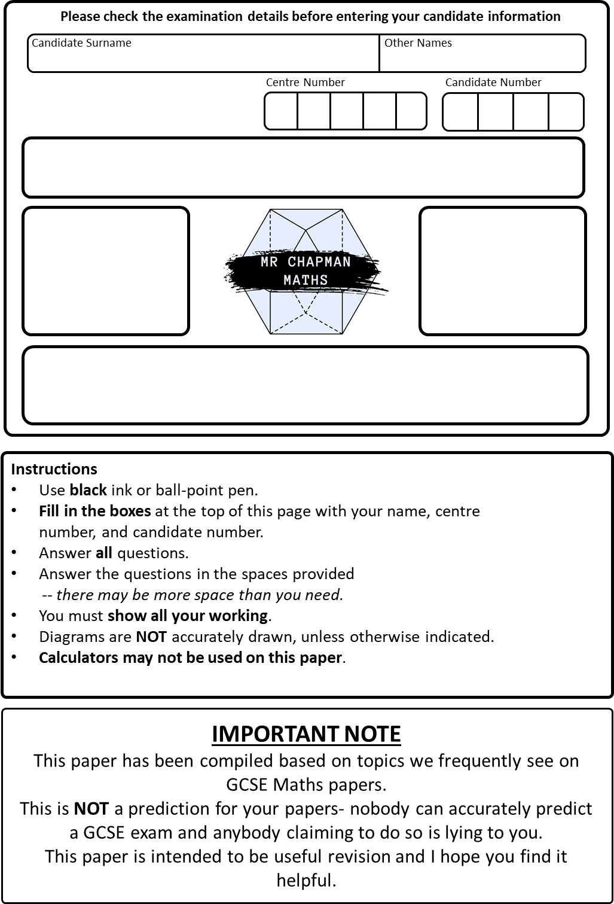
Write your answers in the spaces provided.
You may use a calculator on this paper.
Best Guess Paper 2 2026
P
Marks:
/80
GCSE
Foundation Tier
Paper 1
Mathematics
You must write down all the stages in your working.
1. a. Write $7\%$as a decimal.

…………………………
$(1$mark)
b. Write $0.625$as a fraction in its simplest form

………………………
($2$marks)
Total for question: 3 marks

2. Gemma usually buys a carton of pineapple juice that is $400$ml.
She buys a special edition that contains an extra $35\%$.
How many millilitres of juice are in the special edition of the carton?

…………………………….
$(3$marks)
3. Arrange these measurements in order, from smallest to largest.
$1.2$kg$, 5$ kg $, 800$g$, 90$g$, 0.6$ kg

………………………………….…………………………
$(2$marks)
4. A café has the following items on the menu, alongside their costs:

MENU
Sandwich | £2.95
Panini | £3.75
Crisps | 85p
Tea | £1.50
Coffee | £2.10
Can of Soda | 90p

- Devon buys seven cups of coffee and three cups of tea. How much does this cost in total?

……………………………….
(2 marks)
- Patrick has a £5 note and three 50p coins. He buys a panini, a packet of crisps, and a can of soda. How much change does he receive?

……………………………….
(3 marks)
Total for question: 5 marks

5. Lucas scores $28$out of $45$ on his music assessment. Give his score as a percentage, to one
decimal place.

…………………………………………………………….
(2 marks)

6. There are 200 pupils in Year 7.

$23$pupils do not wear glasses.
$10$male pupils do not wear glasses.
$95$of the pupils are male.

Use this information to complete this frequency tree.

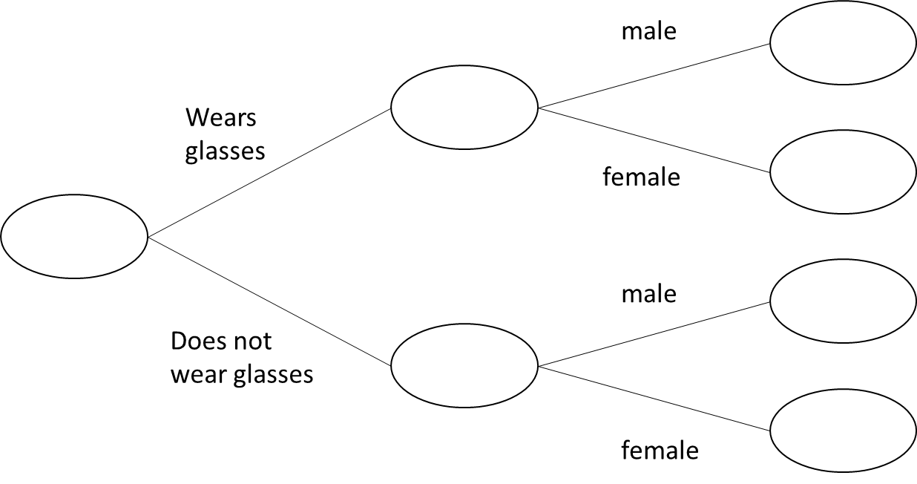

(3 marks)

7. A box contains blue counters and green counters only.
$20\%$of the counters are blue.
Write the ratio of blue to green counters as a ratio in its simplest form.

…………………………………..
$(2$marks)

8. Work out $\frac{2}{3}$of $103$, giving your answer correct to $1$decimal place.

…………………………………….
(2 marks)

9. Use your calculator to work out the value of

$$\frac{5.21+6.37}{9.8}+{8.3}^{2}$$
Write down all of the figures on your calculator display.

………………………………………….
(2 marks)
10. Simplify:
- $f+f+f+f+f$

………………………………………….
(1 mark)
- $8y+2z-2y+4z$

………………………………………….
(1 mark)
- $t^{4}+t^{4}$

………………………………………….
(1 mark)
Total for question : 3 marks

11. A car travels $90$miles in $2$hours $30$minutes. What is the average speed of the car, in miles per hour?

………………………………………
(2 marks)
12. a. Write $7,450,000,000$in standard form.

…………………………………………
(1 mark)
- Write $2.5×{10}^{-4}$ as an ordinary number.

…………………………………
(1 mark)
Total for question: 2 marks

13. On the grid below, translate Shape A by the vector $\left(\begin{matrix}6 \\ -1 \end{matrix}\right)$ and label it B.
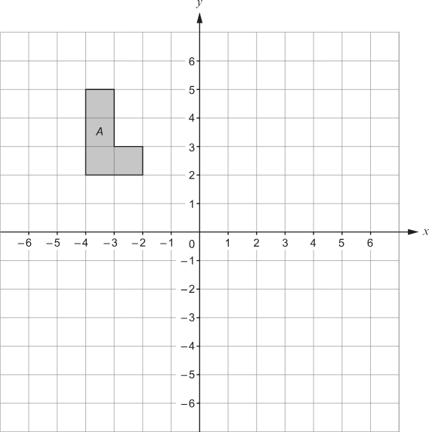

(2 marks)

14. Find the highest common factor (HCF) of $63$and $105$

…………………………………………….
(2 marks)
15. Solve

- $\frac{y}{8}=-6$

$y=$………………
(1 mark)
- $25-x=18$

$x=$…………….
(2 mark)
c. $5\left(2f-1\right)=6f+9$

$f=$………………………
$(3$marks)
Total for question : 6 marks

16. Roberto runs a fruit stand and he sells strawberries in boxes.
This frequency table shows the number of strawberries that are in $130$boxes.

Number of strawberries | Frequency
15 | 7
16 | 24
17 | 35
18 | 37
19 | 18
20 | 9

Calculate the mean number of strawberries in a box

…………………………………………….
(3 marks)

17. Simplify

- $y^{15}÷y^{3}$

………………………….
(1 mark)
- ${\left(m^{8}\right)}^{6}$

…………………………..
(1 mark)
- $8×{\left(4t\right)}^{0}$

……………………….
(2 marks)
Total for question: 4 marks
18. Shown is a right-angled triangle

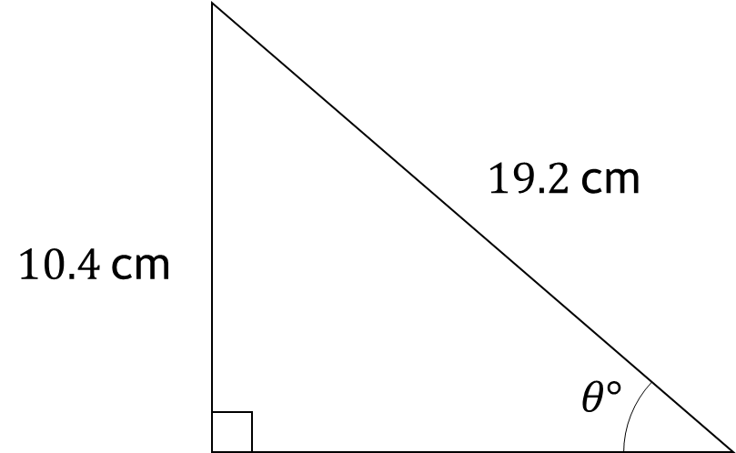

Work out the size of angle $θ$, giving your answer to $1$decimal place.

……………………….
(2 marks)

19. The diagram shows a rectangle measuring $4$cm by $9$cm.
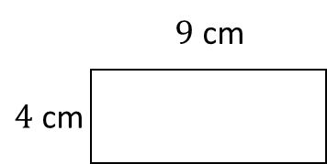
A shape is made by combining $3$of these rectangle as shown below

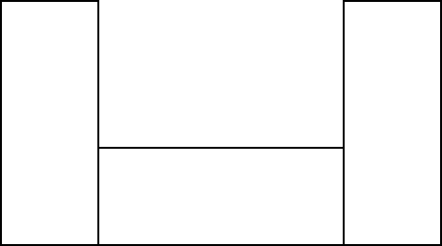

Work out the perimeter of the shape.

……………………………….
(3 marks)
20. Solve $2x+5≥11$ and represent your solution on the number line below

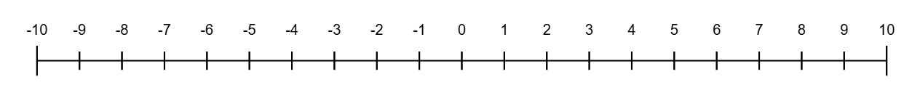
(4 marks)

21. In a village

the number of houses and the number of flats are in the ratio 7 : 4
the number of flats and the number of bungalows are in the ratio 8 : 5

There are 50 bungalows in the village.

How many houses are there in the village?

(3 marks)
22. Tabitha buys a new car for £35,000

The value of the car depreciates by $20$% by the end of the first year.
It then depreciates by $12$% at the end of every year after that.

Work out the value of the car by the end of $3$years.

……………………………….
(3 marks)

23. Find the volume of the triangular prism shown below.
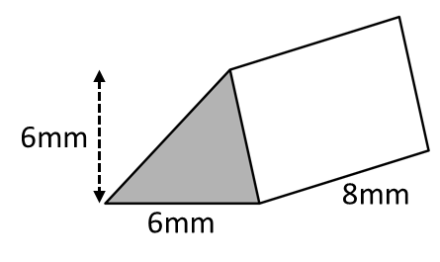

…………………………………
(3 marks)

24. The first two terms of a Fibonacci sequence are

$$a, b$$

Find the fifth term in this sequence.

………………………………………
(3 marks)

25.
$$ξ=\left\{Odd numbers less than 30\right\}$$
$$A=\left\{3, 9, 15, 21, 27\right\}$$
$$B=\left\{5, 15, 25\right\}$$
- Complete the Venn Diagram to show this information

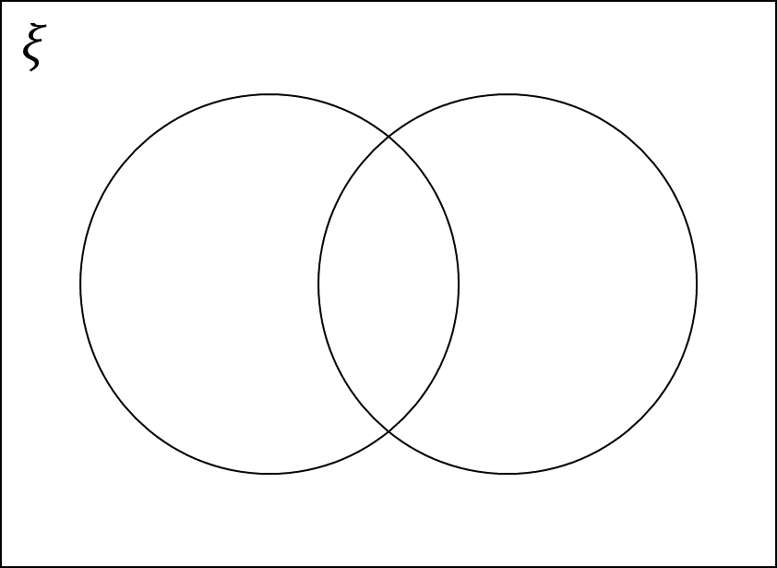
- A number is chosen at random from the universal set $ξ$ .
What is the probability the number is in the set $A∪B$.

…………………………… (2 marks)
Total for question : 6 marks

26.
a. Complete the table $y=x^{2}+x+2$

$$x$$ | $$-3$$ | $$-2$$ | $$-1$$ | $$0$$ | $$1$$ | $$2$$
$$y$$

(2 marks)
b. On the grid below, draw the graph of $y=x^{2}+x+2$for the values from $-3$to $2$
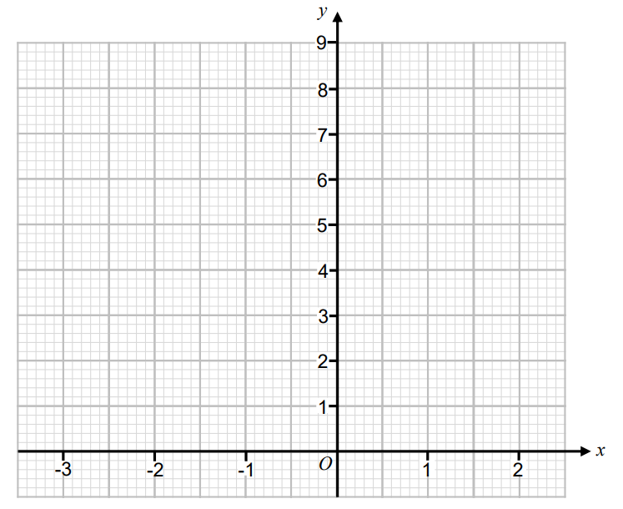
(2 marks)

- Write down an estimate for the co-ordinate of the turning point of this graph.

………………………………
(1 mark)
TOTAL FOR PAPER IS $80$MARKS

