Mr Chapman Maths
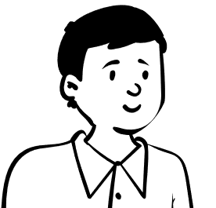
’Last Third’ Questions
With Mark Scheme Hints

This paper contains questions that are in the last third of marks of a Mock GCSE Exam paper (Mock Set 2 Spring 2017 Paper 3F)
At the end of each question there are hints to where the marks are awarded on the mark scheme – you might find it useful to use these hints to help you structure your solutions.

Name: _________________________________
Teacher: _______________________________

Question 1
​Solve the simultaneous equations
​$2x+3y=10$
​$4x-y=-1$

………………………….
(3 marks)
M1 | For matching a variable and eliminating by either adding or subtracting the equations.
M1 | For substituting a value for $x$or $y$ into one of the original equations in order to find the other.
A1 | Correct answer.

Question 2
​​$A$ is the point with coordinates ​$\left(2,10\right)$
​$B$ is the point with coordinates ​$\left(5,d\right)$
The gradient of the line ​$AB$ is 4
Work out the value of ​$d$.

​​$d=$ …………………………
(3 marks)
P1 | Process to use the gradient formula.
P1 | Process to rearrange the equation to solve for $d$.
A1 | Correct answer.

Question 3
​Sophia pays £222 for a plane ticket.
She also pays 100 euros airport tax.
The exchange rate is $£1 = 1.38$euros.
What percentage of the total cost of the ticket and the airport tax does Sophia pay for the airport tax?
Give your answer correct to 1 decimal place.

………………………… ​%
(3 marks)
P1 | Process to use the conversion rate (either changing Euros into £ or the other way round).
P1 | Process to find the percentage Sophia pays for airport tax.
A1 | Correct answer.

Question 4
​A sofa has $6$ identical cushions.
Each cushion is a cuboid $18$ cm by $80$ cm by $95$ cm.
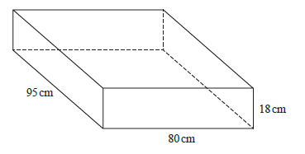
The cushions are covered with a protective spray.
The protective spray is in cans.
The label on each can has this information.
Spray in this can covers $4m^{2}$
- Work out how many cans are needed to cover the $6$ cushions with protective spray.

………………………… ​cans
(5 marks)
P1 | Unit conversion into metres.
P1 | Find the area of at least 2 different faces.
P1 | Find the total surface area of one cushion.
P1 | For multiplying your total surface area by $6$and dividing by $4$.
A1 | Correct answer.

The information on each label is inaccurate.
The spray in each can covers $10\%$ more than $4m^{2}$
- How will this affect the number of cans needed for the 6 cushions?
You must show how you get your answer.

(2 marks)
P1 | Show that if you increase the spray by $10\%$that it changes the number of cans required.
C1 | For a written statement describing what you have worked out.

Question 5
​​$a=\left(\begin{matrix}1 \\ 4\end{matrix}\right)$ and ​$b=\left(\begin{matrix}3 \\ 2\end{matrix}\right)$
- Write down as a column vector ​$a + b$
​​
…………………………
(1 mark)
B1 | Correct answer
- Write down as a column vector ​$2a + 3b$

………………………… ​​
(2 marks)
M1 | For either multiplying either $a$by $2$or $b$by $3$
A1 | Correct Answer

Question 6
​The height (​$x$ cm) and the width (​$y$ cm) of TVs are in the ratio ​$9:16$.
- Use this information to draw a graph to show the relationship between the height and the width of TVs.
Use values of ​$x$ from 20 to 80
​ 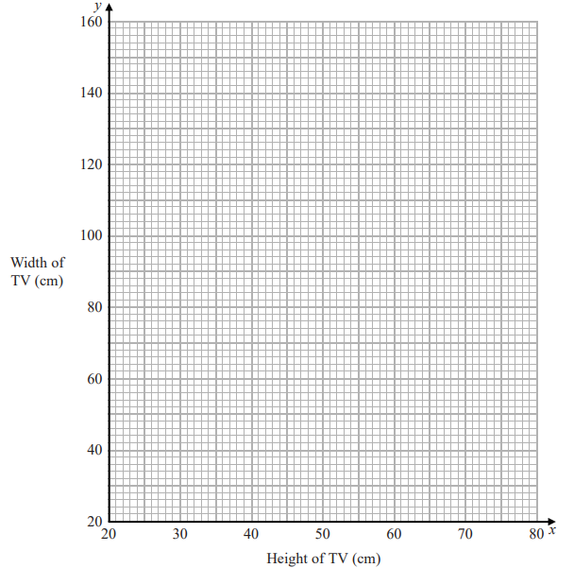
(2 marks)
M1 | For plotting at least two points of a line you intend to draw.
C1 | For drawing a correct line

Another TV has a width of $90$cm.
- Use your graph to work out the height of this TV.

………………………… ​cm
(1 mark)
B1 | For a reasonable correct answer using the line you have drawn.

​

Question 7
​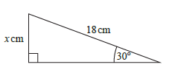
Work out the value of ​$x$.

​​$x=$ ………………………… ​cm
(2 marks)
M1 | For a correct equation involving the correct trig ratio.
A1 | For a correct answer.

Question 8
​In a sale, normal prices are reduced by 17%.
The normal price of a washing machine is reduced by £42.50
Work out the sale price of the washing machine.

​£ …………………………
(3 marks)
M1 | For a correct first first step to find another percentage e.g. $1\%$.
M1 | For a fully correct method to find the sale price.
A1 | For a correct answer.

Question 9
​​$p^{2}×{ p}^{n}{=p}^{6}$
Find the value of ​$n$.
​​$n=$ …………………………
(1 mark)
B1 | For a correct answer.

Question 10
$$ξ=\left\{1,2,3,4,5,6,7,8,9,10,11,12,13\right\}$$
$A=\{$Multiples of $3$}
$B=\{$Even numbers}
Complete the Venn Diagram for this information.
​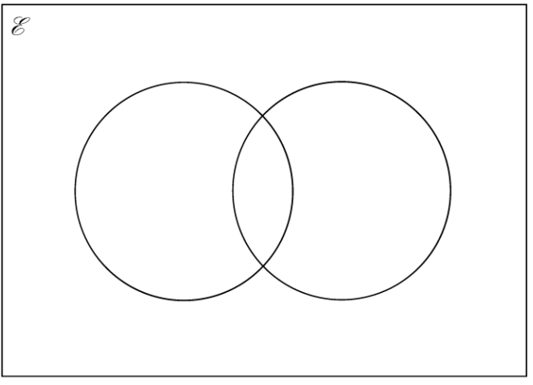
B1 | For labelling the circle
M1 | For correct numbers in at least one region
M1 | For correct numbers in at least two regions
A1 | For a fully correct answer

Mark scheme

Question 1
​​$x = \frac{1}{2}, y = 3$

​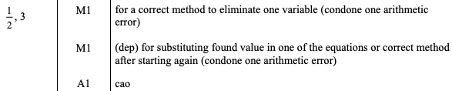

Question 2
​​$d=$22

​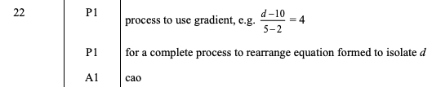

Question 3
​24.6%

​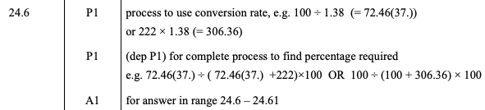

Question 4
- ​4cans

​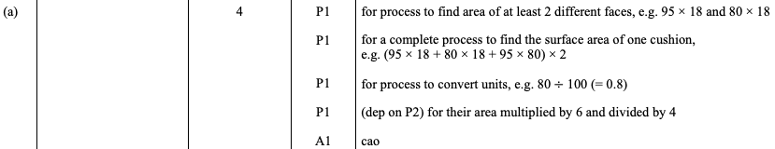
- ​Reduces the number of cans needed.

​

Question 5

​​$\left(\begin{matrix}4 \\ 6\end{matrix}\right)$

​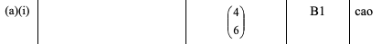
- ​​$\left(\begin{matrix}11 \\ 14\end{matrix}\right)$

​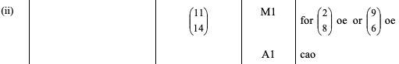

Question 6

a)
​ 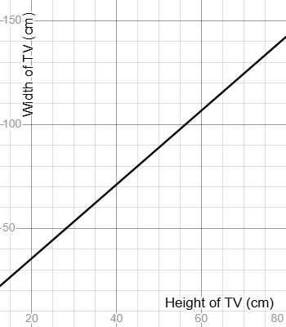

​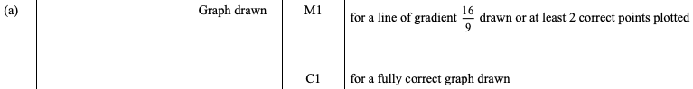

b)
48-52 ​cm

​

Question 7
​​$x=$9cm

​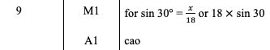

Question 8
​£207.50

​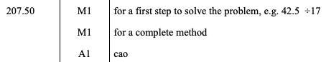

Question 9
​​$n=$4

​

Question 10

