Polar Integration
Single Curves
These are easier but you should still do them, as there are some important points you may have forgotten!
- Find the exact area of the finite region bounded by the curve with polar equation $r=2\sec{θ}$ and the half-lines $θ=0$ and $θ=\frac{π}{4}$
- A curve has polar equation $r=4\cos{2θ}$. Find the exact area of a single loop of the curve.
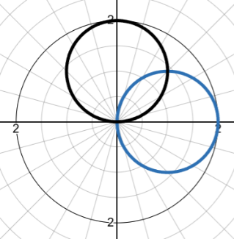
- The curve $C$ has the equation $r=a(2+\cos{θ)}$, where $a$is a positive constant. Show that the total area enclosed by $C$is $\frac{9πa^{2}}{2}$.
Overlapping regions
You have to find an area enclosed by two curves for each of these, so consider how you need to split the integral up. Remember, if it’s tricky… draw a piccy.
4. The diagram shows the curves with equations $r=2\cos{θ}$ and $r=2\sin{θ}$ for $0≤θ≤\frac{π}{2}$
- Find the coordinates of the point of intersection of the two curves.
- Find the exact area of the finite region contained within both curves.
Question 4

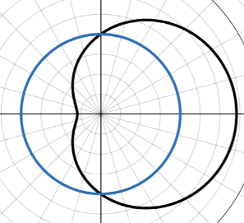
- Find the area of the region enclosed by the circle $r=3$ and the cardioid
$r=3(1-cosθ)$
6. The curves with equations $r=1+\sin{θ}$ and $r=3\sin{θ}$ intersect twice in the region $0≤θ≤2π$. The finite region $R$is contained within both curves. Find the area of $R$.
7. Two curves have polar equation $r=2+\sqrt{2}\cos{θ}$and $r=2$.
- Find the polar coordinates of the points of intersection of the two curves.
- Find the exact area of the region that lies inside $r=2+\sqrt{2}\cos{θ}$but outside $r=2$
Question 7
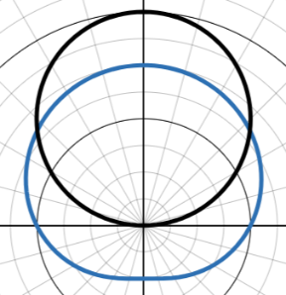
Harder Questions & Links to Loci
8. $r=1+\sin{θ}$ and $r=3\sin{θ}$ are shown below
- Find the values of $θ$ at the points of intersection of the curves.
- Find the exact area of the finite region contained within both curves, giving your answer in the form $pπ+q\sqrt{3}$, where $p,q∈R$

Question 8

9. A complex region $R$is defined on an Argand diagram by $A=\left\{z:\frac{π}{2}≤\arg{z}≤π\right\}∩\{z:\left|z+12-5i\right|≤13\}$
- Sketch the region $R$on an Argand Diagram
- Find the area of the region defined by $R$correct to $3$significant figures.

10. The curves $C_{1}$ and $C_{2}$ have polar equations $r=a(1+\cos{θ) }$and $r=a(1-\cos{θ})$ respectively. Show that the exact region common to the interiors of both curves is $\frac{a^{2}}{2}(3π-8)$

Solutions
- Find the exact area of the finite region bounded by the curve with polar equation $r=2\sec{θ}$ and the half-lines $θ=0$ and $θ=\frac{π}{4}$
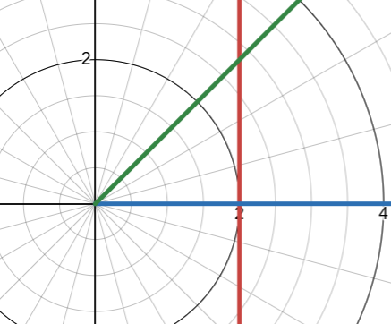
These form a triangle, which has a hypotenuse of $2\sec{\frac{π}{4}}=2\sqrt{2}$
Given the half-line is $y=x$ , this is a right angled triangle with base $2$and height $2$. The Area is then $\frac{1}{2}×2×2=2$units².
Or…
$A=\frac{1}{2}\int_{0}^{\frac{π}{4}}{4\sec^{2}{θ dθ}}=2{\left[\tan{θ}\right]}_{0 }^{\frac{π}{4}}$
$$A=2\left(\tan{\frac{π}{4}}-\tan{0}\right)=2$$
- A curve has polar equation $r=4\cos{2θ}$. Find the exact area of a single loop of the curve.
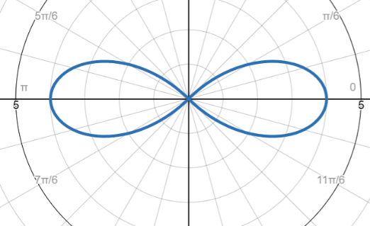
Loop meets the pole at $\frac{π}{4}$, $-\frac{π}{4}$
$$A=2×\frac{1}{2}\int_{0}^{\frac{π}{4}}{(16\cos^{2}{2θ)}dθ}$$
Apply $\cos^{2}{θ=\frac{1}{2}+\frac{1}{2}\cos{2θ}}$
$$A=2×\frac{1}{2}\int_{0}^{\frac{π}{4}}{(16\cos^{2}{2θ)}dθ}$$
$$A=\int_{0}^{\frac{π}{4}}{(8+8\cos{2θ})d θ}=8\int_{0}^{\frac{π}{4}}{(1+\cos{2θ})d θ}$$
$$={\left[θ+\frac{1}{2}\sin{2θ}\right]}_{0}^{\frac{π}{4}}$$
$$=2π$$
- The curve $C$ has the equation $r=a(2+\cos{θ)}$, where $a$is a positive constant. Show that the total area enclosed by $C$is $\frac{9πa^{2}}{2}$.
$$A=\frac{1}{2}\int_{0}^{2π}{a^{2}{\left(2+cosθ\right)}^{2} dθ}$$
$$=\frac{a^{2}}{2}\int_{0}^{2π}{4+4\cos{θ}+\cos^{2}{θ} dθ}$$

$$=\frac{a^{2}}{2}\int_{0}^{2π}{4+4\cos{θ}+\frac{1}{2}+\frac{1}{2}\cos{2θ} dθ}$$

$$=\frac{a^{2}}{2}{\left[\frac{9}{2}θ+4\sin{θ}+\frac{1}{4}\sin{2θ}\right]}_{0}^{2π}$$
$$=\frac{a^{2}}{2}\left(9π\right)$$
$$=\frac{9πa^{2}}{2}$$

4. The diagram shows the curves with equations $r=2\cos{θ}$ and $r=2\sin{θ}$ for $0≤θ≤\frac{π}{2}$
- Find the coordinates of the point of intersection of the two curves.
- Find the exact area of the finite region contained within both curves.
- Solve $2\cos{θ=2\sin{θ}}$
Divide through by $2\cos{θ}$
$$tanθ=1$$
$$θ=\frac{π}{4}$$
Because these circles are the same size, the region enclosed by both symmetrical in the line $θ=\frac{π}{4}$.
Question 4
Therefore, find the area enclosed by $r=2\cos{θ}$ from $θ=0$ to $θ=\frac{π}{4}$ and double.
$$A=2×\frac{1}{2}\int_{0}^{\frac{π}{4}}{{\left(2\sin{θ}\right)}^{2} dθ}= \int_{0}^{\frac{π}{4}}{4\sin^{2}{θ} dθ}$$
$$=2\int_{0}^{\frac{π}{4}}{1-\cos{2θ} dθ}=2{\left[θ-\frac{1}{2}\sin{2θ}\right]}_{0}^{\frac{π}{4}}$$
$$=\frac{π}{2}-1$$
- Find the area of the region enclosed by the circle $r=3$ and the cardioid $r=3(1-cosθ)$
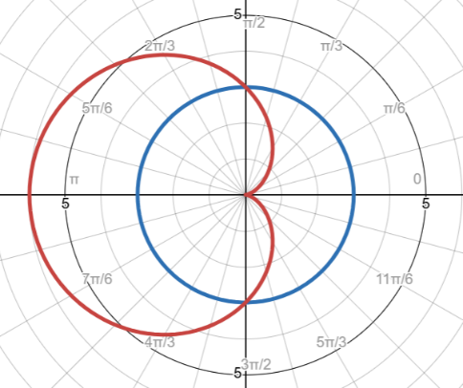
Find intersections:
$$3=3\left(1-\cos{θ}\right)$$
$$cosθ=0$$
$$θ=±\frac{π}{2}$$
Symmetry across the initial line therefore calculate the upper half and double it.
From $0$ to $\frac{π}{2}$ the cardioid is closer, then from $\frac{π}{2}$to $π$ the circle is closer.
$$Area=2×\left[\frac{1}{2}\int_{0}^{\frac{π}{2}}{9{\left(1-cosθ\right)}^{2}dθ}+\frac{1}{2}\int_{\frac{π}{2}}^{π}{3^{2} dθ}\right]$$
$$=9\int_{0}^{\frac{π}{2}}{\frac{3}{2}-2cosθ+\frac{1}{2}\cos{2θ}dθ}+9{\left[θ\right]}_{\frac{π}{2}}^{π}$$
$$=9[\frac{3}{2}θ-2\sin{θ+\frac{1}{4}{\sin{2θ]}}_{0}^{\frac{π}{2}}}+\frac{9π}{2}$$
$$=\frac{45π}{4}-18$$
6. The curves with equations $r=1+\sin{θ}$ and $r=3\sin{θ}$ intersect twice in the region $0≤θ≤2π$. The finite region $R$is contained within both curves. Find the area of $R$.
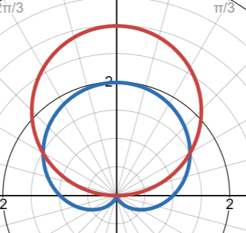
Points of intersection
$$1+\sin{θ=3\sin{θ}}$$
$$sinθ=\frac{1}{2}$$
$$θ=\frac{π}{6},\frac{5π}{6}$$
There is symmetry about the $y$ axis therefore
$$A=2×\left(\frac{1}{2}\int_{0}^{\frac{π}{6}}{(3\sin^{2}{θ)}dθ}+\frac{1}{2}\int_{\frac{π}{6}}^{\frac{π}{2}}{{\left(1+sinθ\right)}^{2} dθ}\right)$$
$$=\int_{0}^{\frac{π}{6}}{9\sin^{2}{θ}dθ+}\int_{\frac{π}{6}}^{\frac{π}{2}}{1+2\sin{θ+\sin^{2}{θ}}dθ}$$
$$=\int_{0}^{\frac{π}{6}}{\frac{9}{2}(1-\cos{2θ} dθ+}\int_{\frac{π}{6}}^{\frac{π}{2}}{1+2\sin{θ+\frac{1}{2}(1-\cos{2θ})} dθ}$$
$$={\left[\frac{9}{2}θ-\frac{9\sin{2θ}}{4}\right]}_{0}^{\frac{π}{6}}+{\left[\frac{3}{2}θ-2\cos{θ-\frac{1}{4}(\sin{2θ)}}\right]}_{\frac{π}{6}}^{\frac{π}{2}}$$
$$=\frac{3π}{4}-\frac{9\sqrt{3}}{8}+\frac{π}{2}+\frac{9\sqrt{3}}{8}$$
$$=\frac{5π}{4}$$

7. Two curves have polar equation $r=2+\sqrt{2}\cos{θ}$and $r=2$.
- Find the polar coordinates of the points of intersection of the two curves.
- Find the exact area of the region that lies inside $r=2+\sqrt{2}\cos{θ}$but outside $r=2$
- $r=2+\sqrt{2}\cos{θ}=2$
$θ=\frac{π}{2},\frac{3π}{2}$
Coordinates are $\left(2,\frac{π}{2}\right)$ and $(2 ,\frac{3π}{2}$)
- The outer curve is $r=2+\sqrt{2} cosθ$ between $-\frac{π}{2}$ and $\frac{π}{2}$ , and the inner curve is $r=2$.
$$A=\frac{1}{2}\int_{-\frac{π}{2}}^{\frac{π}{2}}{{\left(2+\sqrt{2}\cos{θ}\right)}^{2}-2^{2} dθ }$$
Symmetrical about the initial line so change limits to $0$ to $\frac{π}{2}$ and double.
$$A= \int_{0}^{\frac{π}{2}}{4\sqrt{2}\cos{θ}+2\cos^{2}{θ} dθ }$$
$$=\int_{0}^{\frac{π}{2}}{4\sqrt{2}\cos{θ+1+\cos{2θ} dθ}={\left[4\sqrt{2}\sin{θ+θ+\frac{1}{2}\sin{2θ}}\right]}_{0}^{\frac{π}{2}}}$$
$$=4\sqrt{2}+\frac{π}{2}$$
8. $r=1+\sin{θ}$ and $r=3\sin{θ}$ are shown below
- Find the values of $θ$ at the points of intersection of the curves.
- Find the exact area of the finite region contained within both curves, giving your answer in the form $pπ+q\sqrt{3}$, where $p,q∈R$

a. $1+\sin{θ=3\sin{θ}}$
Intersect at $θ=\frac{π}{6}$ and $\frac{5π}{6}$
Question 8

$$A=2×\left[\frac{1}{2}\int_{0}^{\frac{π}{6}}{{\left(3\sin{θ}\right)}^{2} dθ}+\frac{1}{2}\int_{\frac{π}{6}}^{\frac{π}{2}}{(1+\sin^{2}{θ)}dθ}\right]$$
$$=\frac{9}{2}\int_{0}^{\frac{π}{6}}{(1-\cos{2θ)}dθ}+\int_{\frac{π}{6}}^{\frac{π}{2}}{\left(\frac{3}{2}+2\sin{θ-\frac{1}{2}\cos{2θ}}\right) dθ}$$
$$=\frac{9}{2}{\left[θ-\frac{1}{2}\sin{2θ}\right]}_{0}^{\frac{π}{6}}+{\left[\frac{3}{2}θ-2\cos{θ-\frac{1}{4}\sin{2θ}}\right]}_{\frac{π}{6}}^{\frac{π}{2}}$$
$$=3π-\frac{9\sqrt{3}}{8}+\frac{3π}{4}-\frac{π}{4}+\frac{5\sqrt{3}}{4}$$
$$=\frac{5π}{4}+\frac{\sqrt{3}}{8}$$

9. A complex region $R$is defined on an Argand diagram by $A=\left\{z:\frac{π}{2}≤\arg{z}≤π\right\}∩\{z:\left|z+12-5i\right|≤13\}$
- Sketch the region $R$on an Argand Diagram
- Find the area of the region defined by $R$correct to $3$significant figures.
- Key points for sketch
$θ=\frac{π}{2}$ and $θ=π$ are half lines at $\frac{π}{2}$ and $π$respectively
$\left|z+12-5i\right|≤13$ is a circle centred on $(-12,5$) with a radius $13$
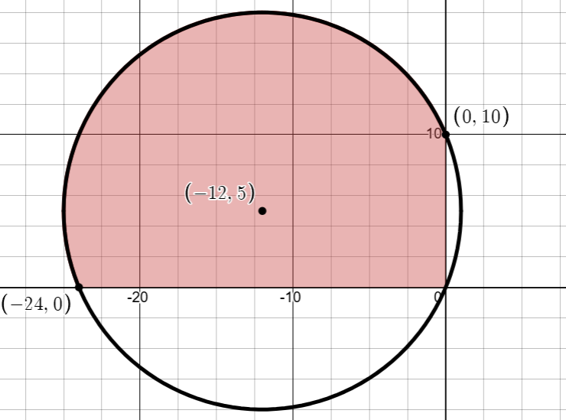
- The circle is ${\left(x+12\right)}^{2}+{\left(y-5\right)}^{2}={13}^{2}$
$${\left(r\cos{θ+12}\right)}^{2}+(r\sin{θ-5)^2=169}$$
$$r^{2}\cos^{2}{θ+24rcosθ+144+r^{2}\sin^{2}{θ-10r\sin{θ+25=169}}}$$
$$r^{2}+24r\cos{θ-10r\sin{θ}}=0$$
Divide $r$without loss of a solution
$$r=10\sin{θ-24\cos{θ}}$$
Hence find the area beneath this polar curve within the limits $θ=\frac{π}{2}$and $θ=π$
$$A=\frac{1}{2}\int_{\frac{π}{2}}^{π}{{\left(10\sin{θ-24\cos{θ}}\right)}^{2} dθ }$$
$$=\frac{1}{2}\int_{\frac{π}{2}}^{π}{576\cos^{2}{θ-480cosθsinθ+100\sin^{2}{θ} }dθ }$$
$$=\frac{1}{2}\int_{\frac{π}{2}}^{π}{288(1+\cos{2θ)-240\sin{2θ+50\left(1-\cos{2θ}\right)}}dθ }$$
$$=\int_{\frac{π}{2}}^{π}{144(1+\cos{2θ)-120\sin{2θ+25\left(1-\frac{1}{2}\cos{2θ}\right)}}dθ }$$
$$={\left[144\left(θ+\frac{1}{2}\sin{2θ}\right)+60\cos{2θ}+25\left(θ-\frac{1}{2}\sin{2θ)}\right)\right]}_{\frac{π}{2}}^{π}$$
$$=385$$

10.. The curves $C_{1}$ and $C_{2}$ have polar equations $r=a(1+\cos{θ) }$and $r=a(1-\cos{θ})$ respectively. Show that the exact region common to the interiors of both curves is $\frac{a^{2}}{2}(3π-8)$
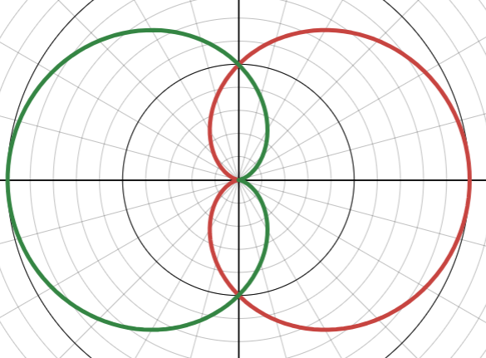
Intersections at $θ=\frac{π}{2}$ and $\frac{3π}{2}$ .
Symmetrical in the line $\frac{π}{2}$ and in the initial line therefore we can find the area from $θ=0$ to $θ=\frac{π}{2}$ and multiply by $4$.
This inner boundary is therefore $r=a(1-\cos{θ)}$
$$A=4×\left(\frac{1}{2}\int_{0}^{\frac{π}{2}}{a^{2}{\left(1-\cos{θ}\right)}^{2}} dθ\right)$$
$$=2a^{2}\int_{0}^{\frac{π}{2}}{a^{2}(1-2\cos{θ+\cos^{2}{θ}) dθ}}$$
$$=2a^{2}\int_{0}^{\frac{π}{2}}{a^{2}(\frac{3}{2}-2\cos{θ+\frac{1}{2}\cos{2θ} ) dθ} }$$
$$=2a^{2}{\left[\frac{3}{2}θ-2\sin{θ+\frac{1}{4}\sin{2θ}}\right]}_{0}^{\frac{π}{2}}$$
$$=2a^{2}\left(\frac{3π}{4}-2+0\right)=\frac{a^{2}}{2}(3π-8)$$

